

2020年1月出版

**CBD15J-Li 步行式电动搬运车**

零件目录

**Administrator**

CBD15/18J-Li2 Walkie Electric Pallet truck

**Part list**

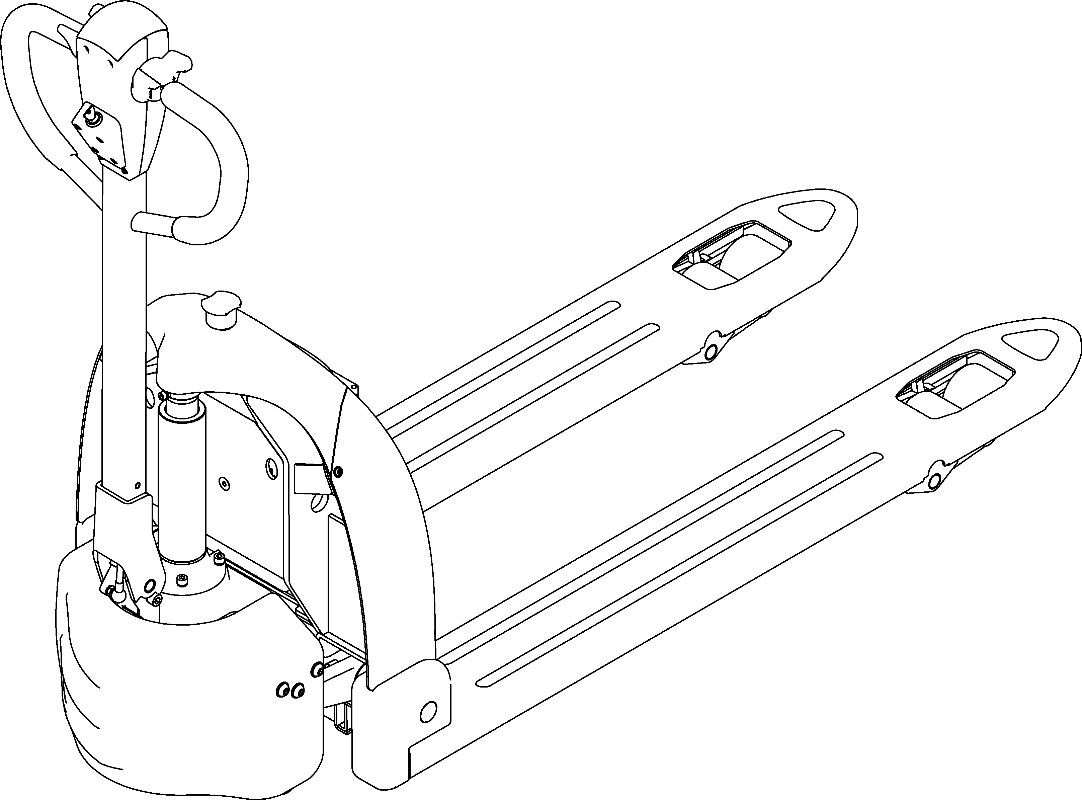

20200316 V01

Content

**1.Body System**

1.1Body System 1

1.2Connecting rod rocker assembly3

**2.Driving System**

2.1Driving assembly5

2.2Driving 7

2.3Balance wheel assembly9

**3.Operating system**

3.1Operating handle11

3.2Operating handle(REMA)13

**4.Hydraulic system**

4.1Hydraulic station assembly15

1.1Body System

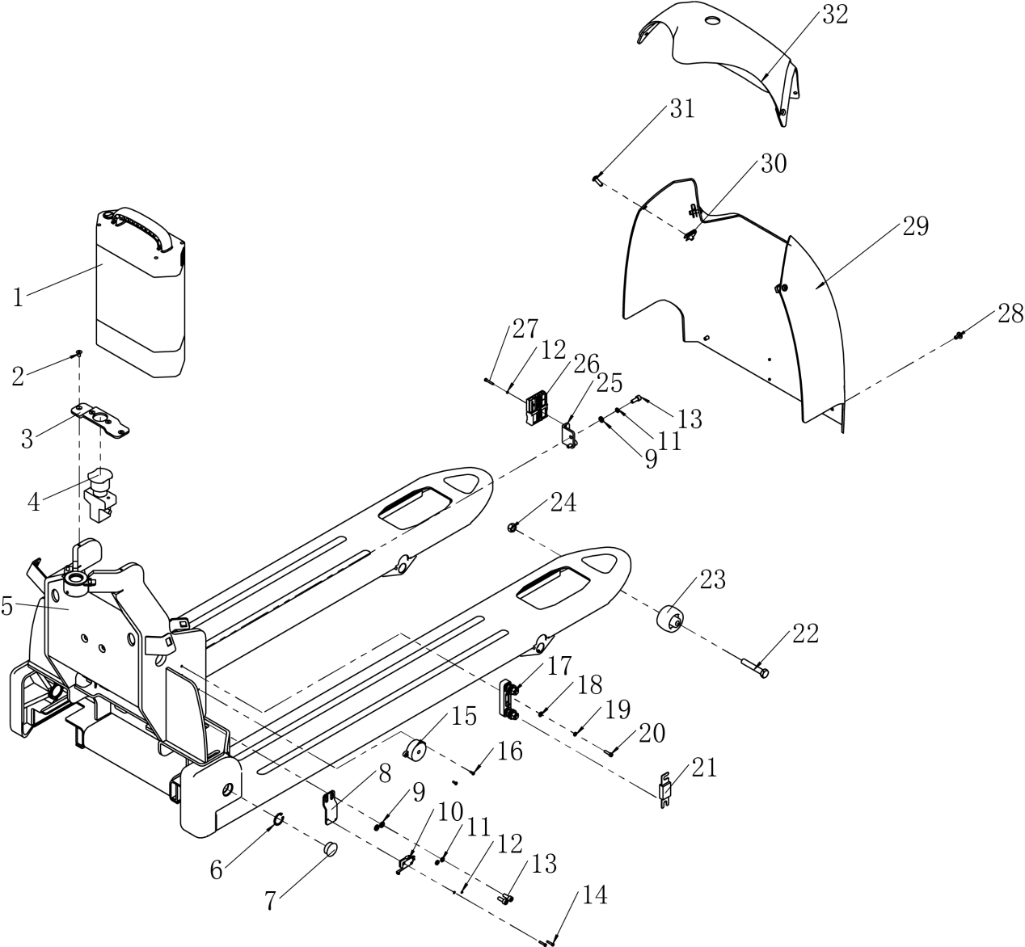

1.1Body System

|  |  |  |  |  |  |
| --- | --- | --- | --- | --- | --- |
| No. | Code | Description | Specification | Qty. | Remark |
| 1 | 02.XDC.3406 | Lithium battery | 24V28AH | 1 |  |
| 2 | 03.0534 | Hexagon socket screw with flat round head | M5×10 | 4 | GB/T 70.2-2000 |
| 3 | 30.46.0029 | Emergency Switch Mounting Plate |  | 1 |  |
| 4 | 02.01.2298 | Emergency Switch | ED80／24V | 1 |  |
| 5 | 33.048.0003 | Main Frame Welded（550) |  | 1 | Standard configuration |
| 33.048.0006 | Main Frame Welded（685) |  | Optional configuration |
| 33.048.0013 | Main Frame Welded（550)Low drop 75 |  | Optional configuration |
| 33.048.0014 | Main Frame Welded （685) low drop 75 |  | Optional configuration |
| 6 | 03.0024 | Circlip for hole | Φ25 | 2 | GB 893.1-86 |
| 7 | 02.01.9167 | Nylon hole plug cover | HP-25 | 2 |  |
| 8 | 30.46.0030 | Micro Switch Mounting plate |  | 1 |  |
| 9 | 03.0049 | Flat Washer | Φ6 | 4 | GB/T 95-2002 |
| 10 | 02.01.2178 | Micro Switch | RV-166S-1C25 | 1 |  |
| 11 | 03.0011 | Spring Washer | Φ6 | 4 | GB/T 93-1987 |
| 12 | 03.00091 | Spring Washer | Φ3 | 4 | GB/T 93-1987 |
| 13 | 03.0147 | Hexagon socket head cap screws | M6×16 | 4 | GB/T 70.1-2000 |
| 14 | 03.05360 | Cross recess pan head screw | M3×16 | 2 | GB/T 818-2000 |
| 15 | 19.03620 | Buzzer（SL13） | 3-24V | 1 |  |
| 16 | 03.02151 | Cross recess pan head screw | M3×8 | 2 | GB/T 818-2000 |
| 17 | 02.01.3057 | Fuse Base | SYY | 1 |  |
| 18 | 03.0055 | Flat Washer | Φ5 | 2 | GB/T 95-2002 |
| 19 | 03.0007 | Spring Washer | Φ5 | 2 | GB/T 93-1987 |
| 20 | 03.0133 | Hexagon socket head cap screws | M5×16 | 2 | GB/T 70.1-2000 |
| 21 | 19.03450 | Fuse （SL15GD） | CNP-100A | 1 |  |
| 22 | 03.03820 | Hexagon head bolt with full thread | M10×60 | 2 | Optional configuration |
| 23 | 30.28.0137 | Roller |  | 2 | Optional configuration |
| 24 | 03.0243 | Hexagon lock nut | M10 | 2 | Optional configuration |
| 25 | 30.46.0031 | Plug-in Mounting plate |  | 1 |  |
| 26 | 16.0470 | Connector | CFDS07500S | 1 |  |
| 27 | 03.0130 | Hexagon socket head cap screws | M3×20 | 2 | GB/T 70.1-2000 |
| 28 | 03.0227 | Cross recess pan head screw | M6×12 | 4 | GB/T 818-2000 |
| 29 | 30.46.0001 | Front cover |  | 1 |  |
| 30 | 03.0587 | Spring snap nut | M6 | 4 |  |
| 31 | 03.0233 | Cross recess pan head screw | M6×20 | 4 | GB/T 818-2000 |
| 32 | 30.46.0004 | Upper cover |  | 1 |  |

1.2Connecting rod rocker assembly

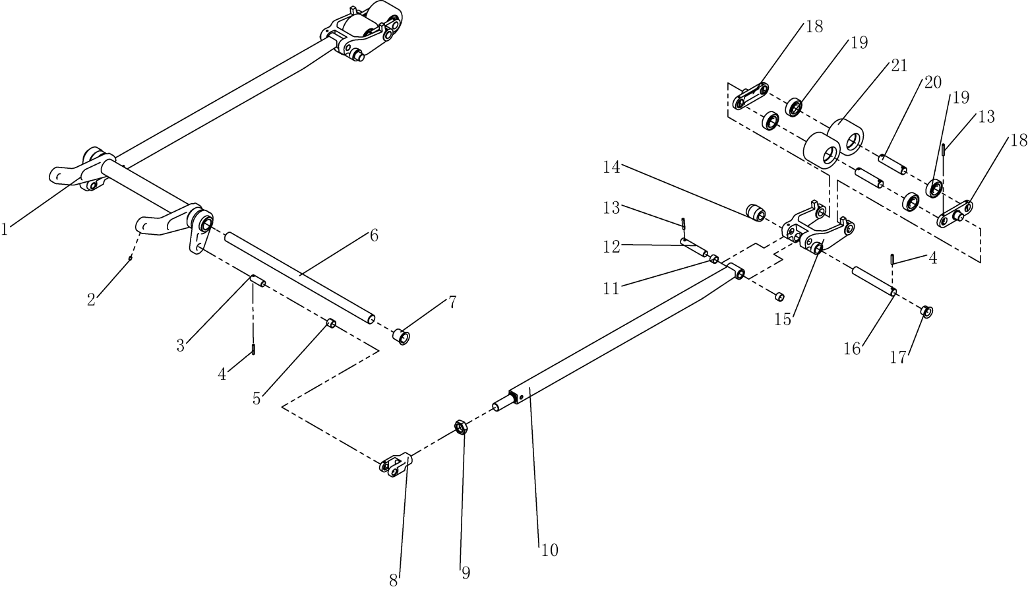

1.2Connecting rod rocker assembly

|  |  |  |  |  |  |
| --- | --- | --- | --- | --- | --- |
| No. | Code | Description | Specification | Qty. | Remark |
| 1 | 33.048.0005 | Round bar welding (550 type) |  | 1 | Standard configuration |
| 33.048.0007 | Round bar welding (685 type) |  | Optional configuration |
| 33.048.0018 | Round bar welding (550 type) low drop 75 |  | Optional configuration |
| 33.048.0019 | Round bar welding (685 type) low drop 75 |  | Optional configuration |
| 2 | 03.0270 | Hexagon socket set screw with flat end | M6×8 | 4 | GB/T 77-2000 |
| 3 | 30.01.6569 | Small Axis |  | 2 |  |
| 4 | 03.0305 | Elastic cylindrical pin | Φ5×30 | 4 | GB/T879.2-2000 |
| 5 | 03.0691 | Composite set | Φ16×Φ19×15 | 2 |  |
| 6 | 30.46.0009 | Support shaft(550 Type) |  | 1 | Standard configuration |
| 30.46.0036 | Support shaft(685 Type) |  | Optional configuration |
| 7 | 03.04422 | Composite set with shoulder | Φ35×Φ28×Φ25×27 | 2 |  |
| 8 | 30.01.6601 | Push-rod bracket |  | 2 |  |
| 9 | 03.0943 | Hexagon thin nut with fin teeth | M22×1.5 | 2 | GB/T 6173-2000 |
| 10 | 33.048.0004 | Push -rod welding （1.5T） |  | 2 | Standard configuration |
| 33.048.0010 | Push -rod welding （1.8T） |  | Standard configuration |
| 33.048.0015 | Push -rod welding （low drop 75） |  | Optional configuration |
| 11 | 03.0451 | Composite set | Φ16×Φ19×12 | 4 |  |
| 12 | 30.28.0093 | Push-Rod mounting Shaft |  | 2 |  |
| 13 | 03.03030 | Elastic cylindrical pin | Φ5×35 | 10 | GB/T879.2-2000 |
| 14 | 30.01.2845 | Drop Out Roller |  | 2 |  |
| 15 | 30.28.0082 | Wheel bracket |  | 2 | Standard configuration |
| 30.28.0200 | Wheel bracket（ low drop 75） |  | Optional configuration |
| 16 | 30.28.0164 | Wheel bracket mounting axis |  | 2 |  |
| 17 | 03.0453 | Composite set with shoulder | Φ31×Φ23×Φ20×16.5 | 4 |  |
| 18 | 30.01.1290 | Connecting plate |  | 4 |  |
| 19 | 03.90.057 | Deep groove ball bearing | 6204 | 8 | GB/T 276-94 |
| 20 | 30.28.0094 | Bearing wheel pin shaft |  | 4 |  |
| 21 | 03.LZ.0128 | Small roller (polyurethane wheels) | Φ80×60 | 4 |  |

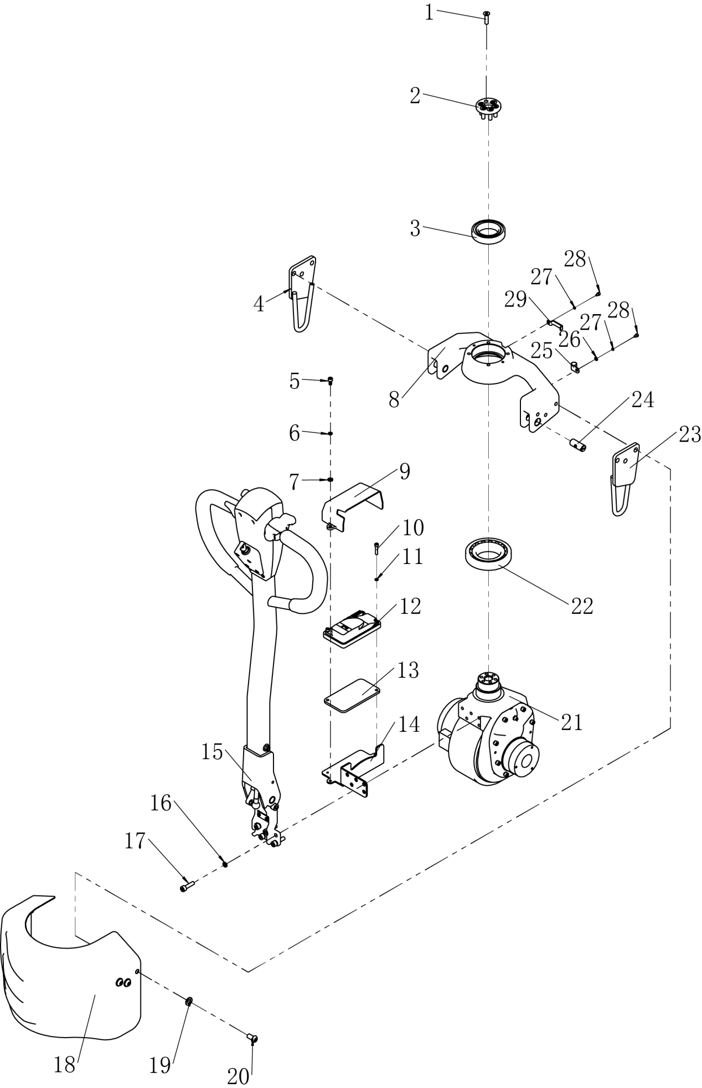2.1Driving assembly

2.1Driving assembly

|  |  |  |  |  |  |
| --- | --- | --- | --- | --- | --- |
| No. | Code | Description | Specification | Qty. | Remark |
| 1 | 03.0117 | Hexagon socket screw with flat round head | M8×16 | 6 | GB/T 70.2-2000 |
| 2 | 30.46.0013 | Drive clamping plate |  | 1 |  |
| 3 | 03.90.018 | Deep groove ball bearing | 6010-2Z | 1 | GB/T 276-94 |
| 4 | 33.048.0001 | Balance frame welding L |  | 1 |  |
| 5 | 03.0145 | Hexagon socket head cap screws | M6×12 | 2 | GB/T 70.1-2000 |
| 6 | 03.0011 | Spring Washer | Φ6 | 2 | GB/T 93-1987 |
| 7 | 03.0049 | Flat Washer | Φ6 | 2 | GB/T 95-2002 |
| 8 | 30.01.6570 | Bearing bridge |  | 1 |  |
| 9 | 30.46.0002 | Mounting cover |  | 1 |  |
| 10 | 03.01410 | Hexagon socket head cap screws | M5×25 | 2 | GB/T 70.1-2000 |
| 11 | 03.0007 | Spring Washer | Φ5 | 2 | GB/T 93-1987 |
| 12 | 02.KZQ.2151 | Controller | 1212P-2501 | 1 | Standard configuration |
| 02.KZQ.2152 | 1212C-2501 | Optional configuration |
| 13 | 02.01.9262 | Aluminum plate |  | 1 |  |
| 14 | 30.46.0014 | Controller mounting plate |  | 1 |  |
| 15 | 81.024.0004 | Operating handle |  | 1 | Standard configuration |
| 81.024.0005 | Operating handle(REMA) | Optional configuration |
| 16 | 03.0013 | Spring Washer | Φ8 | 5 | GB/T 93-1987 |
| 17 | 30.01570 | Hexagon socket head cap screws | M8×30 | 5 | GB/T 70.1-2000 |
| 18 | 30.46.0003  30.46.0046 | Driving cover  Driving cover （With balance wheel ） |  | 1 |  |
| 19 | 03.0043 | Flat Washer | Φ10 | 6 | GB/T 95-2002 |
| 20 | 03.01191 | Hexagon socket screw with flat round head | M10×20 | 6 | GB/T 70.2-2000 |
| 21 | 02.QD.0085 | CLJDriving assembly | 24V/0.75KW | 1 |  |
| 22 | 03.90.023 | Tapered Roller Bearings | 30212 | 1 | GB/T 297-94 |
| 23 | 33.048.0002 | Balance frame welding R |  | 1 |  |
| 24 | 30.01.6595 | Short pin |  | 2 |  |
| 25 | 21.03.04617 | R-shaped hoop (with rubber protection) | Φ16 | 1 |  |
| 26 | 03.0054 | Flat Washer | Φ4 | 1 | GB/T 95-2002 |
| 27 | 03.0008 | Spring Washer | Φ4 | 2 | GB/T 93-1987 |
| 28 | 03.0127 | Hexagon socket head cap screws | M4×6 | 2 | GB/T 70.1-2000 |
| 29 | 30.46.0015 | Wire harness Mounting plate |  | 1 |  |

2.2Driving

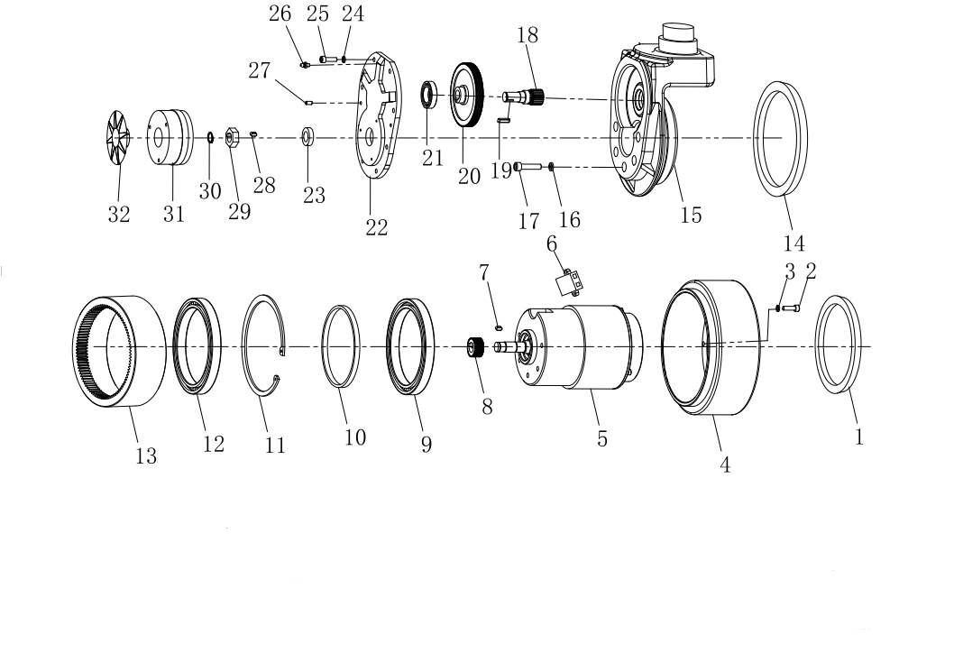

2.2Driving

|  |  |  |  |  |  |
| --- | --- | --- | --- | --- | --- |
| No. | Code | Description | Specification | Qty. | Remark |
| 1 | GB/T13871-92 | Framework oil seal | VC 130*145-10 | 8 |  |
| 2 | 03.01049 | Hexagon socket head cap screws | M6×20 | 8 | GB/T 70.1-2000 |
| 3 | 03.0011 | Spring Washer | Φ6 | 8 | GB/T79-1987 |
| 4 | 1115-220000-0B | Driving wheel |  | 1 |  |
| 5 | Z130D750-24A1-26.5S | Driving motor |  | 1 |  |
| 6 | JX6-2 | Connecting box |  | 1 |  |
| 7 | GB/T1096-2003 | Key 5*5*14 double round head | A type Key | 1 |  |
| 8 | 1115-200005-0B | Small helical |  | 1 |  |
| 9 | GB/T276-94 | Anti-friction bearing61824-2RS | Φ120*Φ150*16 | 1 |  |
| 10 | ZD-NL-571-001 | Adjust Washer | 40CR | 1 |  |
| 11 | GB/T 893.1-86 | Circlip for hole | Φ150 | 1 |  |
| 12 | GB/T276-94 | Anti-friction bearing61824-2RS | Φ120*Φ150*16 | 1 |  |
| 13 | 1115-200002-0B-X | Straight ring | 20CrMnTi | 1 |  |
| 14 | GB/T13871-92 | Framework oil seal | TCΦ155*Φ172*10 | 1 |  |
| 15 | ZD-SJ-504-001 | BOX | QT450 | 1 |  |
| 16 | 03.0013 | Spring Washer | Φ8 | 5 | GB/T79-1987 |
| 17 | 03.0158 | Hexagon socket head cap screws | M8×35 | 5 | GB/T 70.1-2000 |
| 18 | 1115-200003-0B | Small straight tooth |  | 1 |  |
| 19 | GB/T1096-2003 | Ke;y 5*5*20double round head | A type Key | 1 |  |
| 20 | 1115-200004-0B | Large tooth |  | 1 |  |
| 21 | GB/T276-94 | Anti-friction bearing | 61905-ZZ | 1 |  |
| 22 | ZD-RY-505-001 | Box cover | ADC12 | 1 |  |
| 23 | GB/T13871-92 | Framework oil seal | TCΦ16*Φ28*7 | 1 |  |
| 24 | 03.0011 | Spring Washer | Φ6 | 8 | GB/T79-1987 |
| 25 | 03.01049 | Hexagon socket head cap screws | M6×20 | 8 | GB/T 70.1-2000 |
| 26 | JB/T7940.1-1995 | Straight-through injection oil cup |  | 1 |  |
| 27 | GB/T119.1-2000 | Locating pin | 5*15 | 1 |  |
| 28 | GB/T1096-2003 | Key 5*5*8double round head | A type Key | 1 |  |
| 29 | ZD-NL-571-002 | Brake hex |  | 1 |  |
| 30 | GB/T894.1-86 | Circle for shaft | Φ15 | 1 |  |
| 31 | ZD-HZDC-362-001 | 6N.M Brake |  | 1 |  |
| 32 | ZD-ZJNL-076-001 | Brake plug |  | 1 |  |

2.3Balance wheel assembly

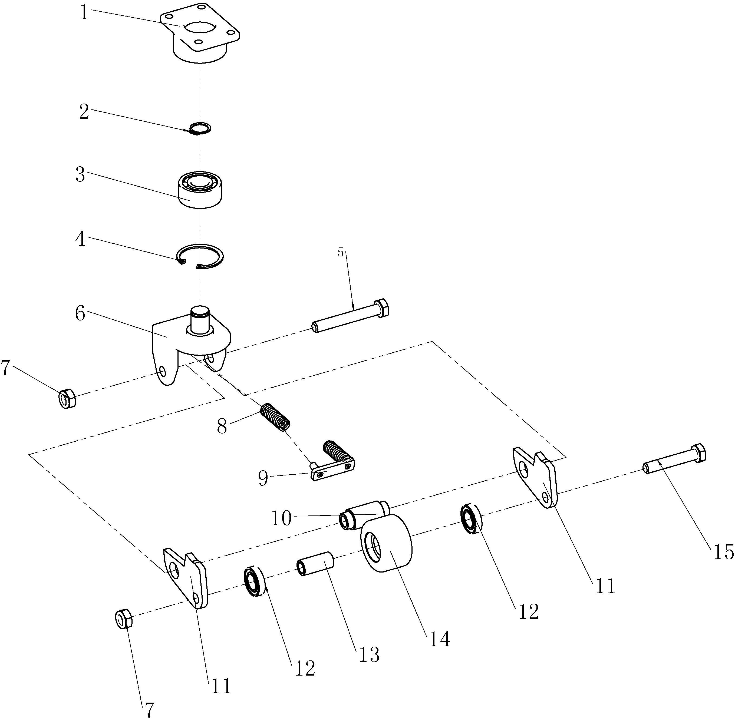

2.3Balance wheel assembly

|  |  |  |  |  |  |
| --- | --- | --- | --- | --- | --- |
| No. | Code | Description | Specification | Qty. | Remark |
| 1 | 03.28.0190 | Flange |  | 1 |  |
| 2 | 03.0063 | Circle for shaft | Φ17 | 1 | GB 894.1-86 |
| 3 | 03.90.0011 | Double-row angular contact ball bearings | 3203A | 1 | GB/T296-94 |
| 4 | 03.0027 | Circle for hole | Φ40 | 1 | GB893.1-86 |
| 5 | 03.0372 | Hexagon bolt | M12×70 | 1 | GB/T 5782-2000 |
| 6 | 30.28.0189 | Bracket |  | 1 |  |
| 7 | 03.0245 | Hexagon lock nut | M12 | 2 | GB/T 889.1-2000 |
| 8 | 03.04790 | Small Spring | 2×12×40 | 2 |  |
| 9 | 33.0146 | Spring limit plate welding |  | 1 |  |
| 10 | 30.28.0079 | Steel sleeve |  | 1 |  |
| 11 | 30.28.0072 | Side plate |  | 2 |  |
| 12 | 03.90.0241 | Deep groove ball bearing | 61902-2Z | 2 | GB/T 276-94 |
| 13 | 30.28.0080 | Sleeve |  | 1 |  |
| 14 | 30.01.6615 | Balance wheel |  | 1 |  |
| 15 | 03.0782 | Hexagon bolt | M12×55 | 1 | GB/T 5782-2000 |

3.1Operating handle

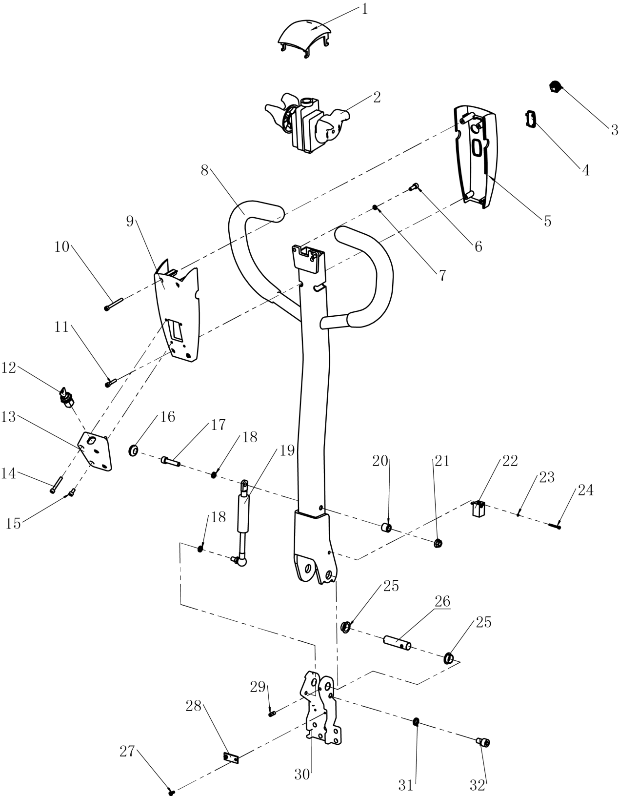

3.1Operating handle

|  |  |  |  |  |  |
| --- | --- | --- | --- | --- | --- |
| No. | Code | Description | Specification | Qty. | Remark |
| 1 | | 16.0038 | Emergency reverse switch |  | 1 |  |
| 2 | | 02.01.2155 | Accelerator（SL15GL） | 24V | 1 |  |
| 3 | | 16.0246 | Metal button | GQ19SH-10 | 3 |  |
| 4 | | 02.DLB.317703 | Electricity meter （SL15GL） | 24V | 1 |  |
| 5 | | 02.FGJ.3415 | Handle upper cover |  | 1 |  |
| 6 | | 03.0147 | Hexagon socket head cap screws | M6×16 | 2 | GB/T 70.1-2000 |
| 7 | | 03.0011 | Spring Washer | Φ6 | 2 | GB/T 93-1987 |
| 8 | | 81.020.0010 | Handle welding |  | 1 |  |
| 9 | | 02.FGJ.3416 | Handle Lower cover |  | 1 |  |
| 10 | | 03.03644 | Hexagon socket head cap screws | M5×50 | 2 | GB/T 70.1-2000 |
| 11 | | 03.01410 | Hexagon socket head cap screws | M5×25 | 2 | GB/T 70.1-2000 |
| 12 | | 02.01.2193 | Key switch | 2801 | 1 |  |
| 13 | | 02.FGJ.0219 | Handle key box |  | 1 |  |
| 14 | | 03.01340 | Hexagon socket head cap screws | M5×35 | 2 | GB/T 70.1-2000 |
| 15 | | 03.0139 | Hexagon socket head cap screws | M5×10 | 2 | GB/T 70.1-2000 |
| 16 | | 02.01.2133 | Shock absorbers |  | 1 |  |
| 17 | | 03.0158 | Hexagon socket head cap screws | M8×35 | 1 | GB/T 70.1-2000 |
| 18 | | 03.0012 | Spring Washer | Φ8 | 2 | GB/T 93-1987 |
| 19 | 02.QTH.3634 | Gas spring assembly |  | 1 |  |
| 20 | 30.46.0054 | Spacer |  | 1 |  |
| 21 | 03.0425 | Hexagon flange nut | M8 | 1 | GB/T 6177.1-2000 |
| 22 | 19.03464 | Proximity Switch | TL-Q5MB1-Z | 1 |  |
| 23 | 03.00091 | Spring Washer | Φ3 | 2 | GB/T 93-1987 |
| 24 | 03.01301 | Hexagon socket head cap screws | M3×25 | 2 | GB/T 70.1-2000 |
| 25 | 03.0452 | Composite set with shoulder | Φ24×Φ18×Φ16×10 | 2 |  |
| 26 | 30.01.6594 | Joint axis |  | 1 |  |
| 27 | 03.0230 | Cross recess pan head screw | M4×10 | 2 | GB/T 818-2000 |
| 28 | 30.28.0109 | Tension disc |  | 1 |  |
| 29 | 03.0270 | Hexagon socket set screw with flat end | M6×8 | 2 | GB/T 77-2000 |
| 30 | 30.46.0011 | Joint bracket |  | 1 |  |
| 31 | 03.0014 | Spring Washer | Φ10 | 1 | GB/T 93-1987 |
| 32 | 03.0162 | Hexagon socket head cap screws | M10×16 | 1 | GB/T 70.1-2000 |

3.2Operating handle(REMA)

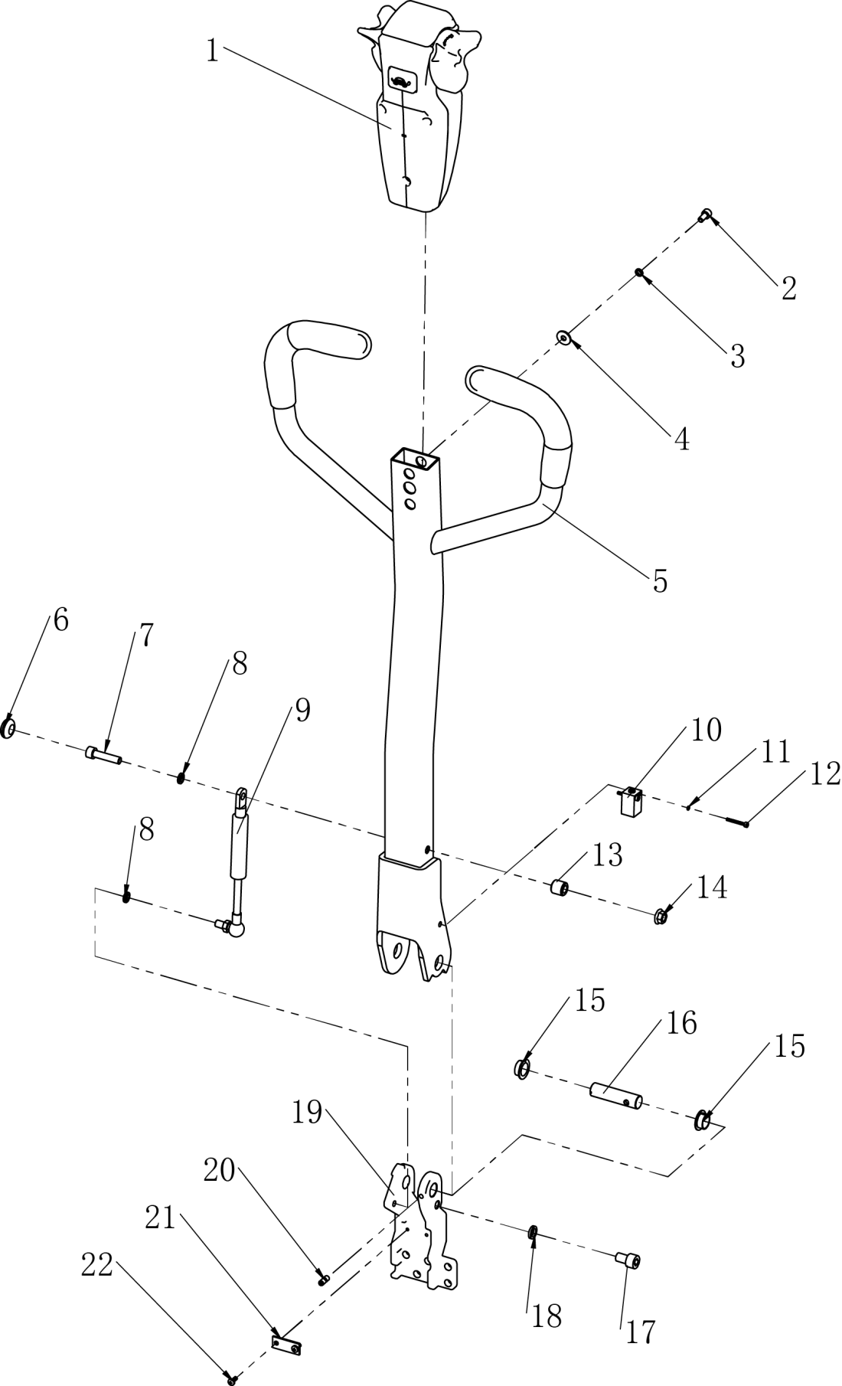

3.2Operating handle(REMA)

|  |  |  |  |  |  |
| --- | --- | --- | --- | --- | --- |
| No. | Code | Description | Specification | Qty. | Remark |
| 1 | | 02.SB.3186 | SL15H Handle（with Electricity meter And password lock) | REMA P/N CAN BUS | 1 |  |
| 2 | | 03.0145 | Hexagon socket head cap screws | M6×12 | 2 | GB/T 70.1-2000 |
| 3 | | 03.0011 | Spring Washer | Φ6 | 2 | GB/T 93-1987 |
| 4 | | 03.0003 | Big washer | Φ6 | 2 | GB/T 96.1-2002 |
| 5 | | 33.048.0009 | Handle welding |  | 1 |  |
| 6 | | 02.01.2133 | Shock absorbers |  | 1 |  |
| 7 | | 03.0158 | Hexagon socket head cap screws | M8×35 | 1 | GB/T 70.1-2000 |
| 8 | | 03.0012 | Spring Washer | Φ8 | 2 | GB/T 93-1987 |
| 9 | 02.QTH.3634 | Gas spring assembly |  | 1 |  |
| 10 | 19.03464 | Proximity Switch | TL-Q5MB1-Z | 1 |  |
| 11 | 03.00091 | Spring Washer | Φ3 | 2 | GB/T 93-1987 |
| 12 | 03.01301 | Hexagon socket head cap screws | M3×25 | 2 | GB/T 70.1-2000 |
| 13 | 30.46.0054 | Spacer |  | 1 |  |
| 14 | 03.0425 | Hexagon flange nut | M8 | 1 | GB/T 6177.1-200 |
| 15 | 03.0452 | Composite set with shoulder | Φ24×Φ18×Φ16×10 | 2 |  |
| 16 | 30.01.6594 | Joint axis |  | 1 |  |
| 17 | 03.0162 | Hexagon socket head cap screws | M10×16 | 1 | GB/T 70.1-2000 |
| 18 | 03.0014 | Spring Washer | Φ10 | 1 | GB/T 93-1987 |
| 19 | 30.46.0011 | Joint bracket |  | 1 |  |
| 20 | 03.0270 | Hexagon socket set screw with flat end | M6×8 | 2 | GB/T 77-2000 |
| 21 | 30.28.0109 | Tension disc |  | 1 |  |
| 22 | 03.0230 | Cross recess pan head screw | M4×10 | 2 | GB/T 818-2000 |

4.1Hydraulic station assembly

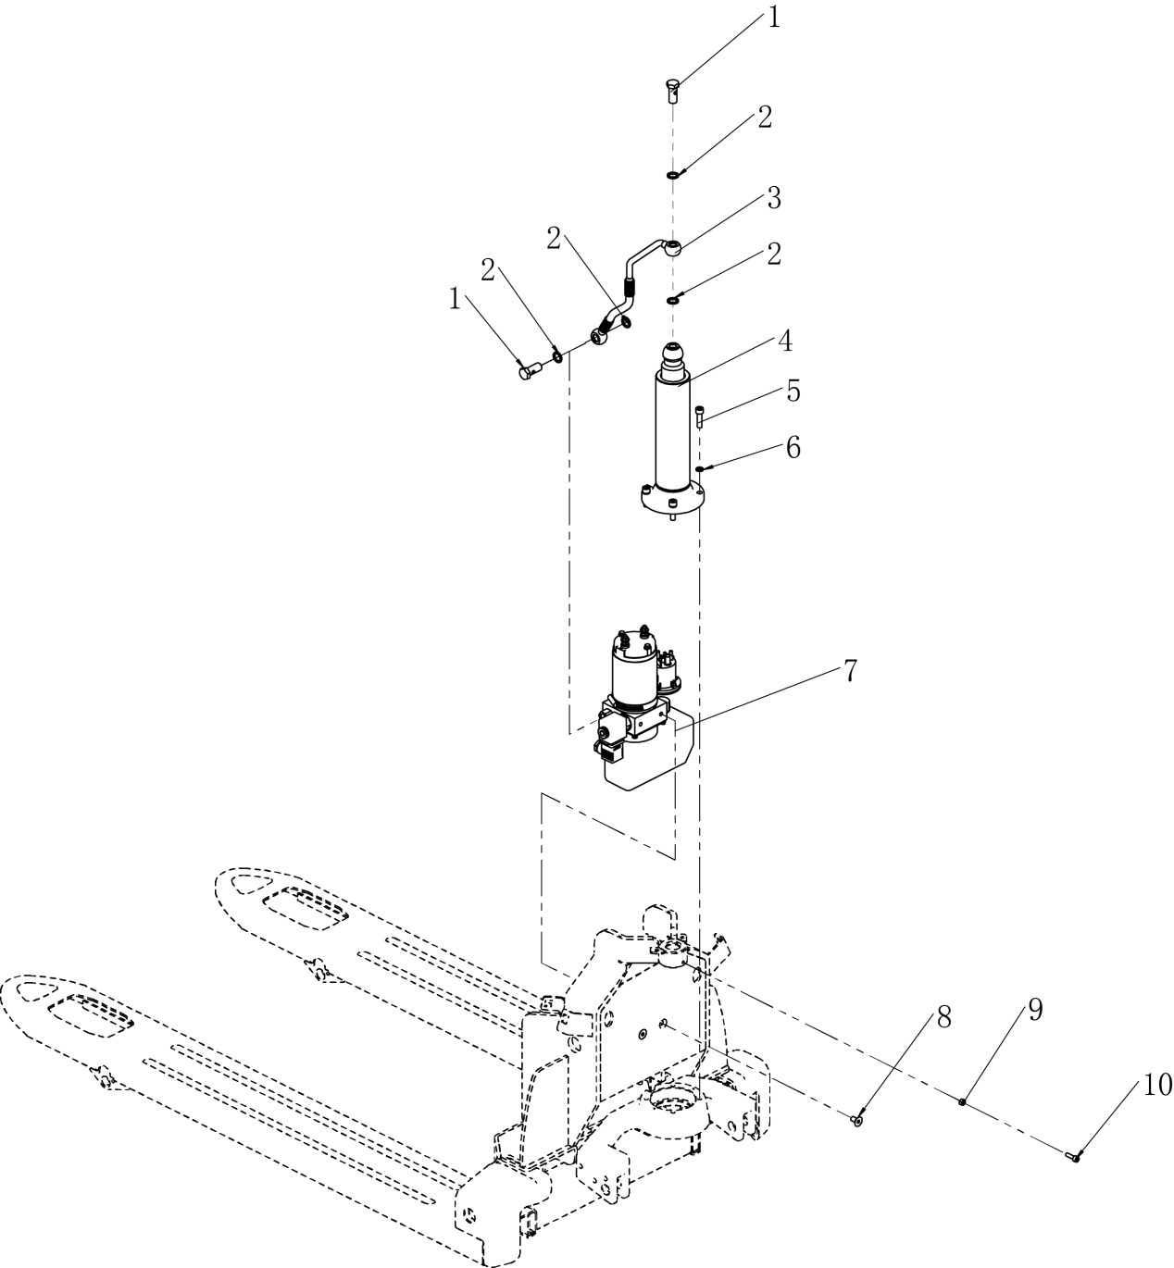

4.1Hydraulic station assembly

|  |  |  |  |  |  |
| --- | --- | --- | --- | --- | --- |
| No. | Code | Description | Specification | Qty. | Remark |
| 1 | 02.01.30810 | Hollow bolt |  | 2 |  |
| 2 | 03.0482 | Combination seal | Φ14 | 4 | GB892-77 |
| 3 | 02.YYL.2422 | Lifting tubing |  | 1 |  |
| 4 | 02.YG.3664 | Cylinder assembly |  | 1 |  |
| 5 | 03.0157 | Hexagon socket head cap screws | M8×30 | 4 | GB/T 70.1-2000 |
| 6 | 03.0012 | Spring Washer | Φ8 | 4 | GB/T 93-1987 |
| 7 | 02.DJ.33617 | SL15H Power unit（JD） | 24V/0.8KW | 1 | Standard configuration |
| 02.DJ.33623 | SL15H Power unit（low drop type） | 24V/0.8KW | Optional configuration |
| 8 | 03.0116 | Hexagon socket countersunk head screw | M8×16 | 2 | GB/T 70.3-2000 |
| 9 | 03.0257 | Hexagon nut | M6 | 1 | GB/T 6170-2000 |
| 10 | 03.0149 | Hexagon socket head cap screws | M6×20 | 1 | GB/T 70.1-2000 |

**The power of interpretation of this part catalogue will be preserved by the manufacturer eventually.**